RANSOM COUNTY BOARD OF COMMISSIONERS
Regular Meeting – March 21, 2023
The meeting was called to order at 9:00 a.m. by Chairman Connie Gilbert. The Pledge of Allegiance was recited. Members present: Mathern, Olerud, Bishop, Schwab, and Gilbert.
Agenda – was reviewed as presented. Schwab asked to have the road department added at 11:30 a.m. Bishop moved, seconded by Mathern. All aye. Motion approved.
Minutes – from the previous regular scheduled commission meeting on March 7, 2023 were reviewed. Bishop moved, seconded by Mathern to approve with corrections. All aye. Motion carried.
Bills – in the amount of $102,527.19 were considered. Mathern moved, seconded by Olerud to approve bills in the amount of $102,527.19. All aye. Motion carried.
Vendor Name | Amount
ALLEGHANY TOWNSHIP | 242.81
ARAMARK UNIFORM SERVICES | 193.64
BALE TOWNSHIP | 375.39
BRAMSTEDT SURGICAL, INC. | 118.84
CARDINAL HEALTH 110, INC. | 4,539.42
CASEY TOWNSHIP | 619.78
COMPUTER EXPRESS | 4,094.00
COUNTIES PROVIDING TECHOLOGY | 2,945.00
CROSSROADS ELECTRIC, INC | 2,470.75
DACOTAH PAPER COMPANY | 453.39
DICKEY RURAL NETWORK INC. | 2,333.99
ELLIOTT TOWNSHIP | 1,409.40
FANTASY FURNITURE | 99.98
FORT RANSOM TOWNSHIP | 440.46
GALLAGHER, RANDY | 16.24
GENTZKOW, NICOLE | 273.42
HEGLE, KELSEY | 116.64
HENRICKS HEATING | 274.15
HOENHAUSE, JODY | 11,781.25
INFORMATION TECHNOLOGY DEPT. | 1,621.95
INTERCOMMUNITY TELEPHONE COMPANY | 75.00
ISLAND PARK TOWNSHIP | 13.16
JOHNSON, HEIDI JO | 107.75
JONES, CHELSEY | 66.81
KELLY, FALLON M. | 3,527.51
LARSON, MEGHAN | 120.20
LAWSON PRODUCTS, INC | 511.04
LIBERTY TOWNSHIP | 967.70
LISBON OIL COMPANY | 25.90
LISBON TRUE VALUE | 139.37
MARCO TECH- ST LOUIS | 600.81
MLGC | 569.88
NAPA PARTS SUPPLY-LISBON | 18.69
ND ASSOC OF COUNTIES- BISMARCK | 7,324.00
ND WEED CONTROL ASSOCIATION | 275.00
PRESTON TOWNSHIP | 507.70
PROUTY,MARIA | 34.50
QUAL, ANGELA | 250.00
RANSOM CO HIGHWAY DEPARTMENT | 37,811.51
RANSOM COUNTY GAZETTE | 362.71
RDO EQUIPMENT-FARGO | 6,233.08
RECORD KEEPERS, LLC | 35.00
RICHLAND COUNTY HEALTH DEPARTMENT | 1,798.67
RIVERSIDE BUILDING CENTER | 638.52
ROSEMEADE TOWNSHIP | 36.73
SARGENT COUNTY DISTRICT HEALTH UNIT | 3,900.86
STURDEVANT'S INC | 7.18
STUTSMAN COUNTY AUDITOR | 114.00
SYDNA TOWNSHIP | 767.52
TRIZETTO PROVIDER SOLUTIONS | 79.20
WELTON, BRENNA | 374.74
WEX HEALTH, INC. | 63.00
ZIMPRICH, BRIAN | 748.95
Total | 102,527.19
9:45 a.m. Gas/Fuel/Propane bids - no bids were received.
10:00 a.m. Gravel/Clay bids –were received from Bear Creek, Camas, Mark Sand and Gravel, Lesmeister, and Hoenhause. Bishop moved to have Hopkins take back bids to review and compile in a spreadsheet, Mathern seconded the motion. Olerud asked to have Hoenhause’s bid clarified.

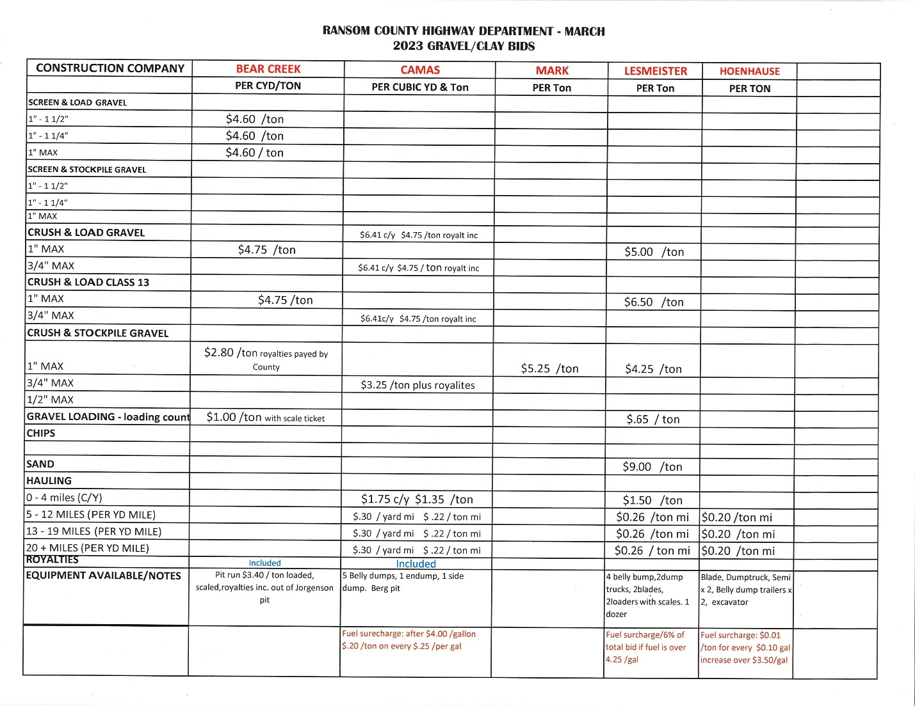

Fuel Bid – Maria Prouty from the deputy auditor brought in a fuel bid from CHS that was not marked properly that was opened with the mail Tuesday morning shortly after 10:00 a.m. Bishop moved, seconded by Mathern to reject the fuel bid from CHS due to it not meeting the bid specs. All aye. Motion carried.
Olerud moved, seconded by Bishop to rebid fuel bids and run in the paper for two weeks. Gilbert, Olerud, Bishop, and Schwab were in favor. Mathern opposed. Motion carried.
10:15 a.m. Motor Grader bid – two bids were presented for motor graders one from RDO and one from Butler Machinery.
 | Purchase | Lease for 5 years | Buyout at the end
RDO | $430,000 | $81,527.11 | $181,915
Butler | $489,743.05 | $95,615.04 | $178,500
Bishop moved, seconded by Olerud to have Hopkins review specs and award at the next meeting at 10:30 a.m. on April 4, 2023. All aye. Motion carried.
Scott Smyth - with KLJ appeared before the board to go over the last round of bridge funding. He let the board know the county did not qualify for any bridge funding in the most recent round. Smyth discussed the advantage of micro surfacing the Elliott and Englevale road, it doesn’t add structural surface but it improves the ride. Micro surfacing is roughly $70,000 a mile versus $250,000 a mile for overlay. Micro surfacing will last about five to ten years and needs to have two layers applied to a road. Smyth also let the board know the Anslem Bridge project is ready for bid letting and the county can expect to see it being bid in May. The slope protection project at the Anslem bridge being done by the Corp should be complete in 2024. KLJ is still waiting on the Sovereign Land permit, however it is possible for it to be bid while they wait for the permit. Smyth asked the board if they still wanted to go through FEMA for the Fox Farm emergency route. Olerud moved, seconded by Bishop to not use FEMA for the Fox Farm emergency route, if the county decides to do something the county will do it on their own. All aye. Motion carried.
Narcan training – Vanessa Bayger with Sargent County and Ransom County Public health appeared before the board to do a presentation on drug overdoses and train on how to use Narcan.
Job Development – Shelly Schwab asked the board to be appointed to the JDA board to represent the townships. Per the century code there should be no fewer than ten members on the JDA board and no more than twenty, there was a list of criteria that should be met with each member including two who represent the townships. Mathern moved, seconded by Schwab to allow Shelly Schwab to be added to the JDA board. A roll call vote was taken: Gilbert – no, Schwab – yes, Bishop – no, Olerud – no, and Mathern – yes. Motion failed.
Highway Department – Neil Olerud and Greg Schwab the highway portfolio holders met with the highway department on Wednesday due to some issues. Both Olerud and Schwab are recommending the termination of Kevin Houge and the asking Hopkins to step down as superintendent and take an operator job. Mathern moved, seconded by Bishop to allow Olerud and Schwab as the portfolio holders of the highway department to meet with Hopkins and work out a plan. All aye. Motion carried.
Ambulance – Gentzkow asked the board what should be budgeted for First Medic in 2023. Gilbert moved to give First Medic the same as 2022, give Milnor $3000, and leave the remainder in the account incase we are required to give some to Lamoure ambulance district.
A special meeting will be held on Thursday March 30, 2023 at 2p.m. to go over the employee handbook.
Being nothing further to come before the board, Chairman Gilbert adjourned the meeting at 1:20 p.m.

___________________________________ _______________________________ Nicole Gentzkow Connie Gilbert, Chairman
Ransom County Auditor Ransom County Commission

